**\*Contributors to the plans for this document:**

- Trieu Huu Phuong

**\*Business Brand Logo Icon that I will design:**

I may use ChatGPT to create icons containing the word RQT, then use MS Designer to design more about it

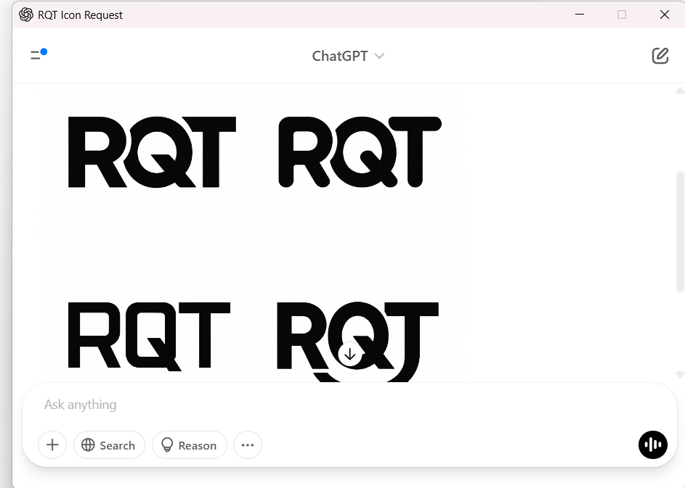

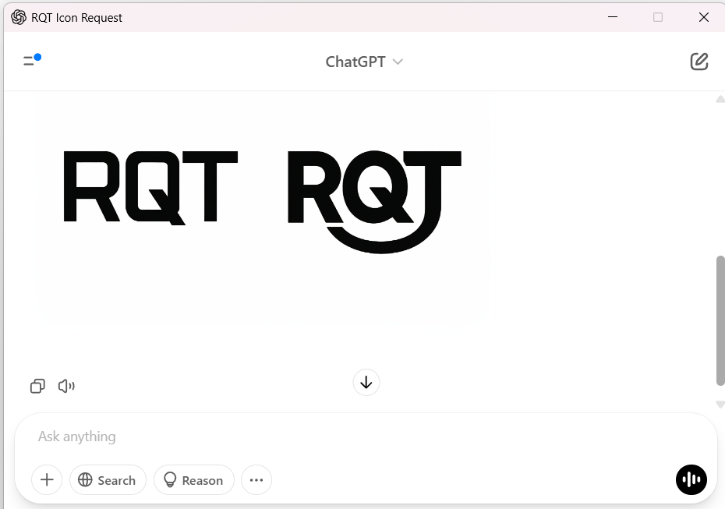

On MS Designer, I finished the design of the logo like this on 04/04/2025 11:37:AM

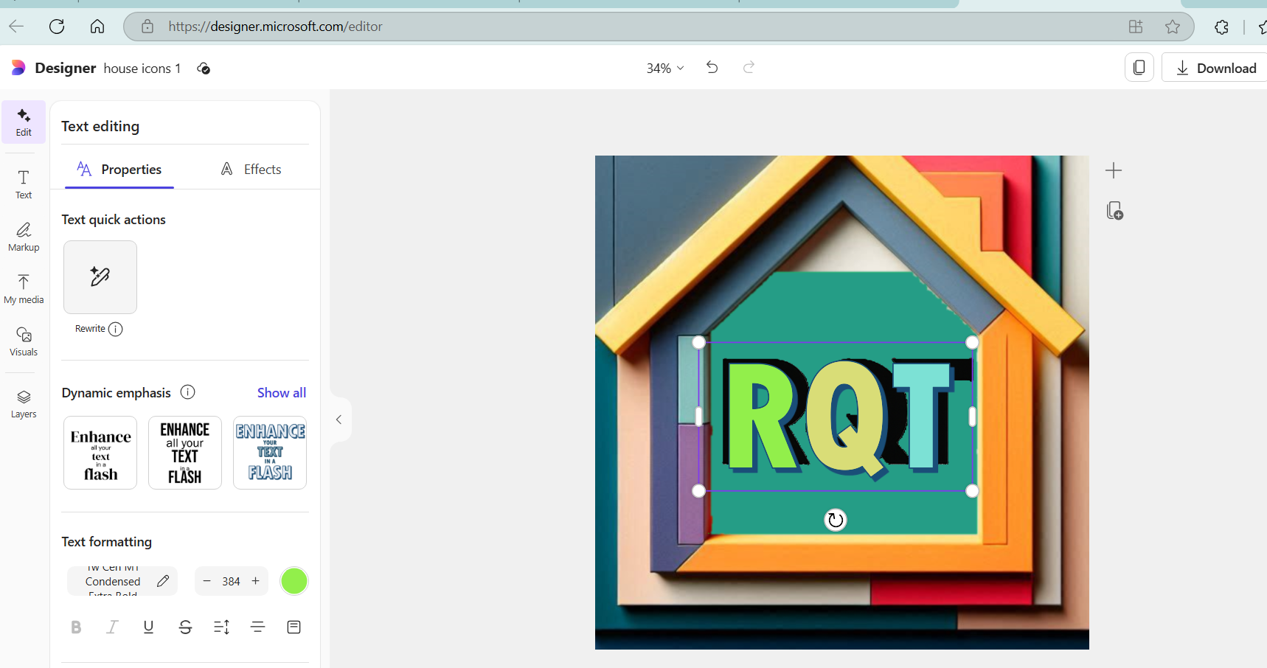

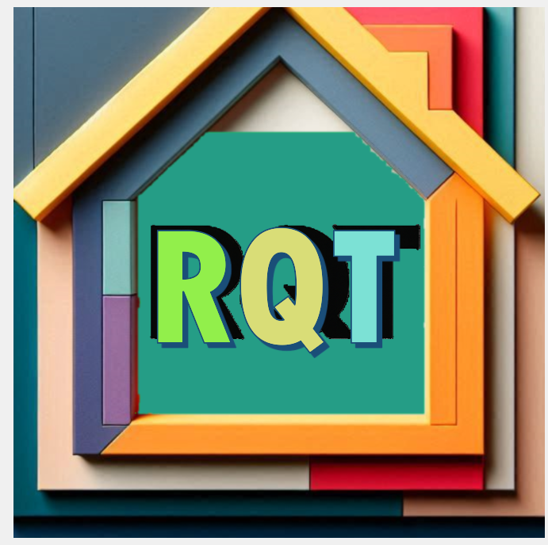

I steps that I did were placing the RQT icon image from ChatGPT into the center of a house template image that the MS Designer was generated for me, change the background color of the icon, then place a new highlighted RQT word into it with different color through each letter.

**\*Technologies, Tools, Pages, Features, Data, or anything that I will contribute:**

|  |  |
| --- | --- |
| **1.Main page Top Navigation Bar** | **2.Main page first poster container** |
| **3.Main page Trending Home container** | **4.Main page calculate budget container** |
| **5.Main page Agents container** | **6.Main page Bottom Navigation Container** |

**1.Main page Top Navigation Bar**

I may make the top navigation bar that looks like this image that comes from website Zillow.com



In our project, on the left side of this navigation bar, I just need 2 buttons (Menu, and AI Assistant).

Menu button will open or close a dropdown menu with 6 items (Buy, Rent, Sell, Home Loans, Find an Agent, and About Us)

On the right side of the top navigation bar, I just need 2 buttons (Help, and Sign In)

I can refer to any of the photos below to have ideas of what kind of buttons or content that I need to create after an user click any button from the top navigation bar

www.homes.com

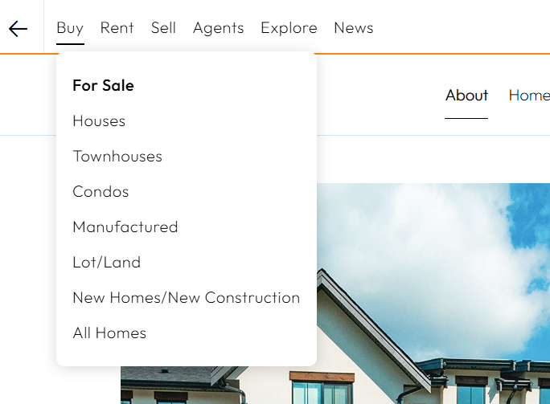

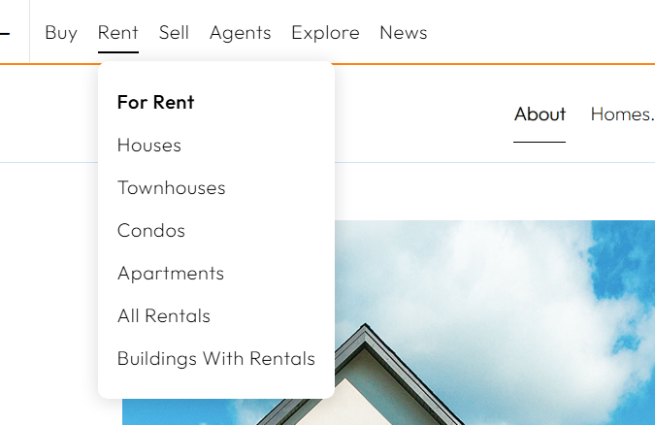

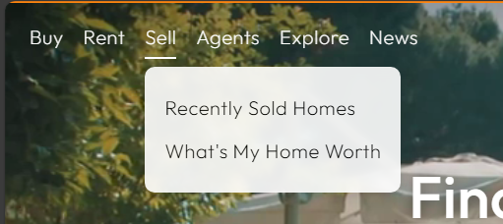

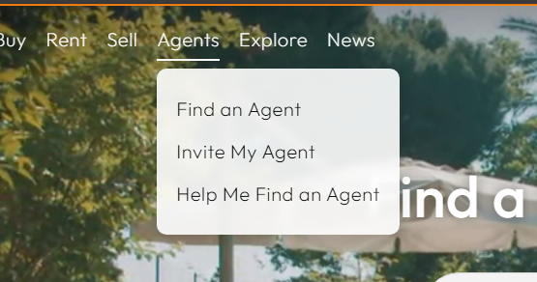

[www.zillow.com](http://www.zillow.com)

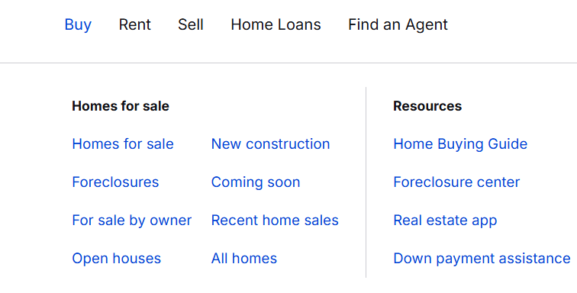

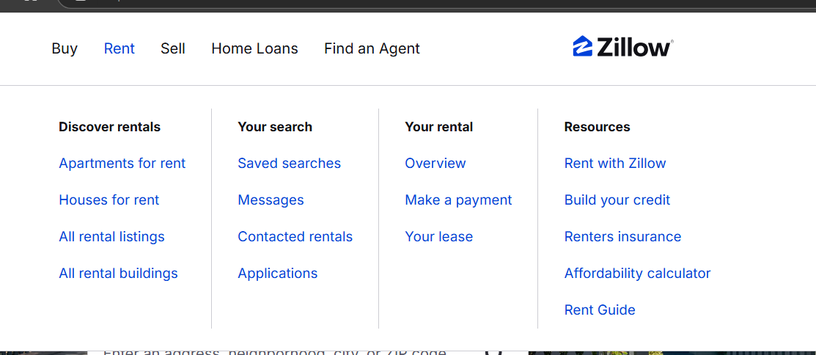

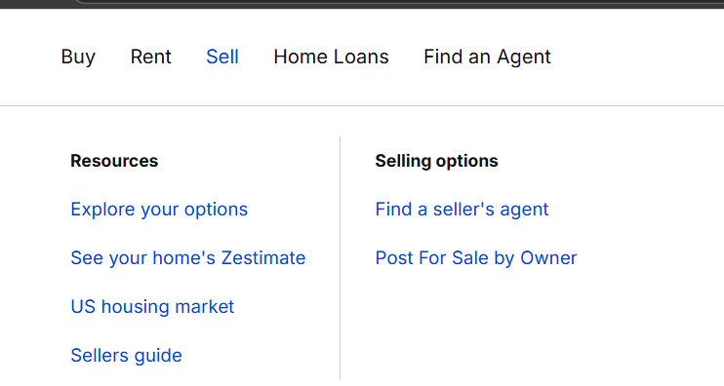

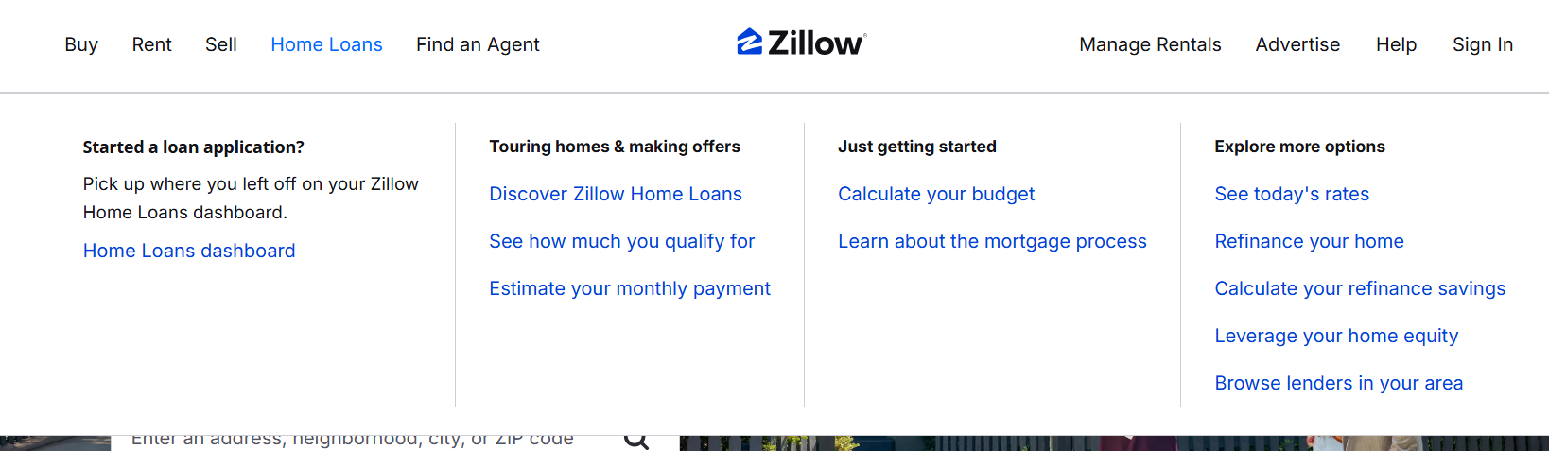

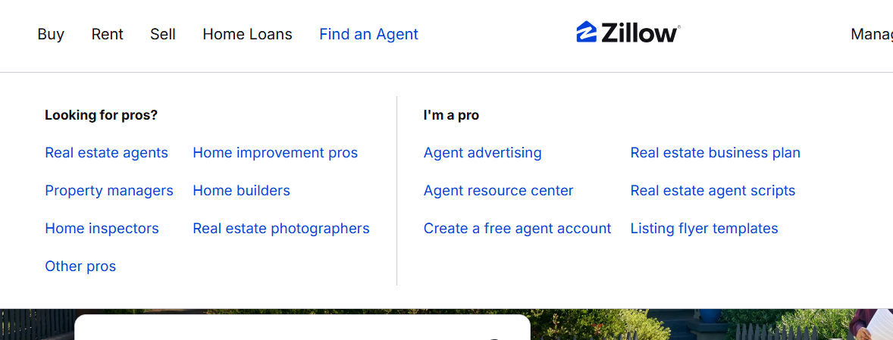

www.realtor.com

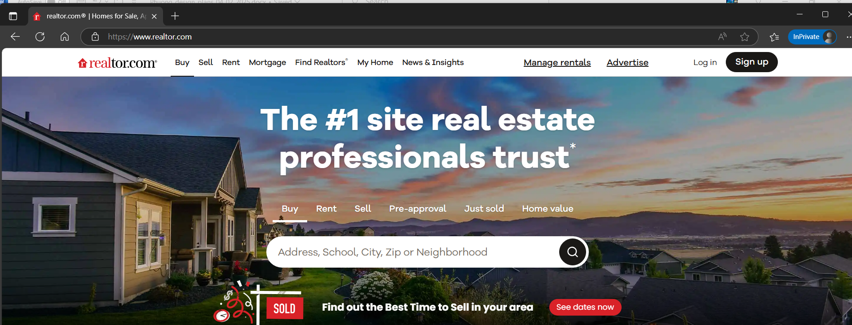

Here’s the design of the top navigation bar that I completed on 04/04/2025 12:14:PM



I need to add some icons into Menu button, Sign-In, and Help buttons like this:

≡ Menu 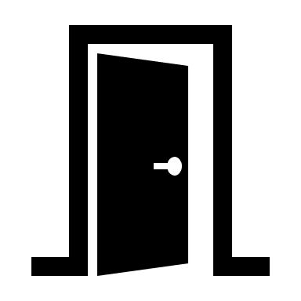Sign-In 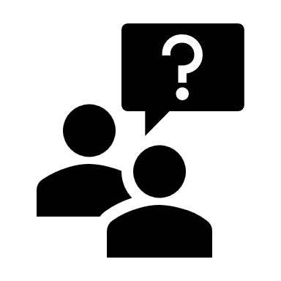Help

**2.Main page first poster container**

I may make the first poster container content from website realtor.com

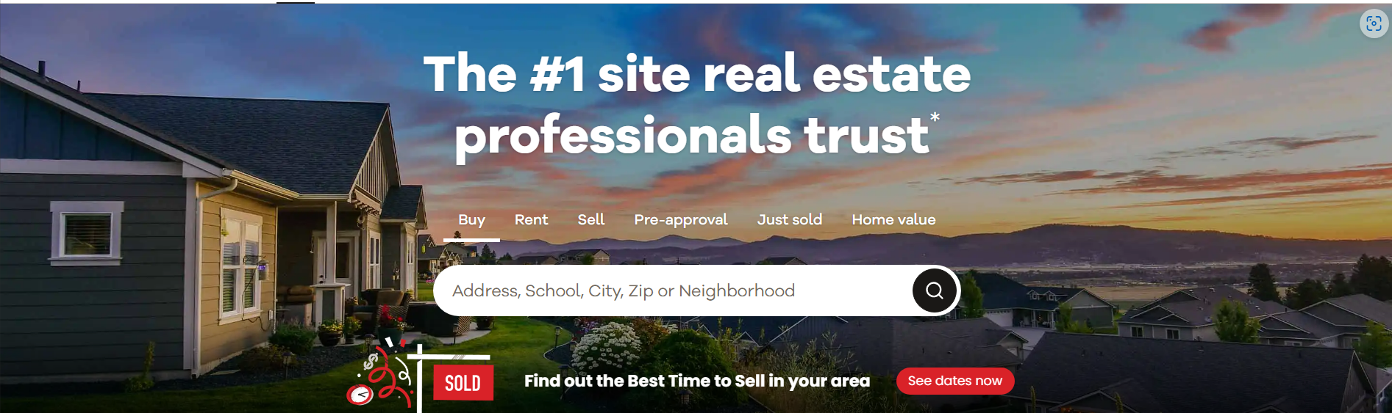

**I’ll use this poster image that I just designed on 04/03/2025**

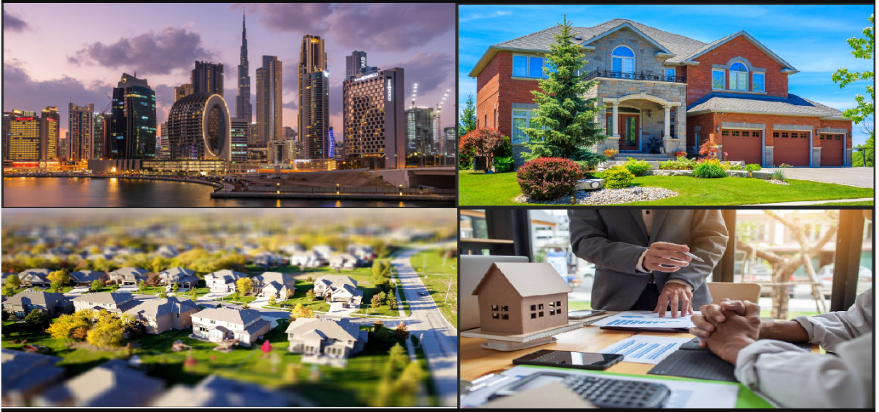

The content that appears in front of the poster must be a box with grayscale effect to make the poster darker a little bit

In front of the grayscale effect box, must be a chatbot to help users input any prompt to help the AI tools help them find their dream house(s).

Above the chatbot is the title: **The #1 AI site real estate professionals trust (font-family: Verdana, font-weight: bold)**



I may use the chatbox design idea from the resources below:

**MS Designer website**

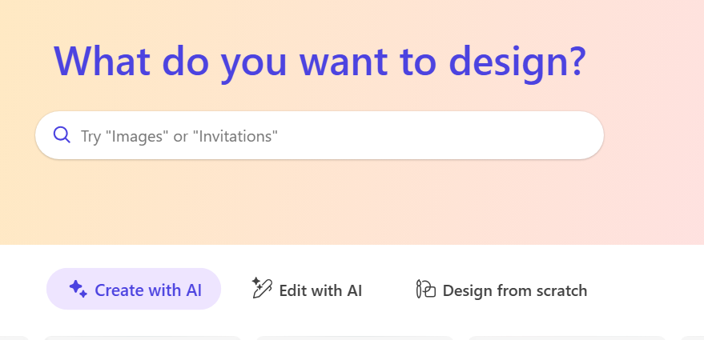

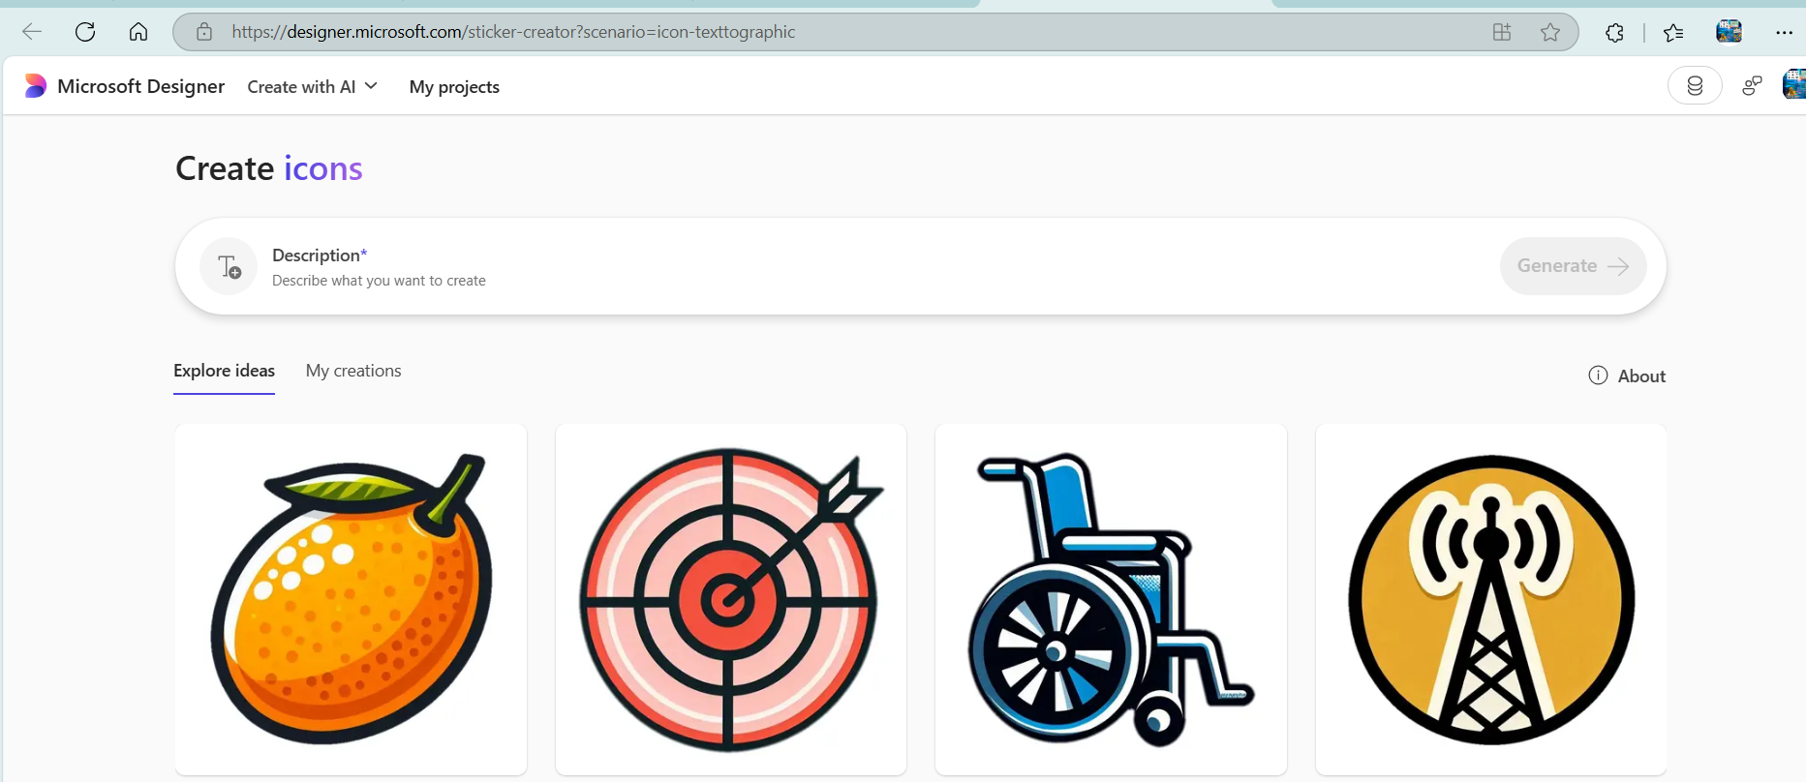

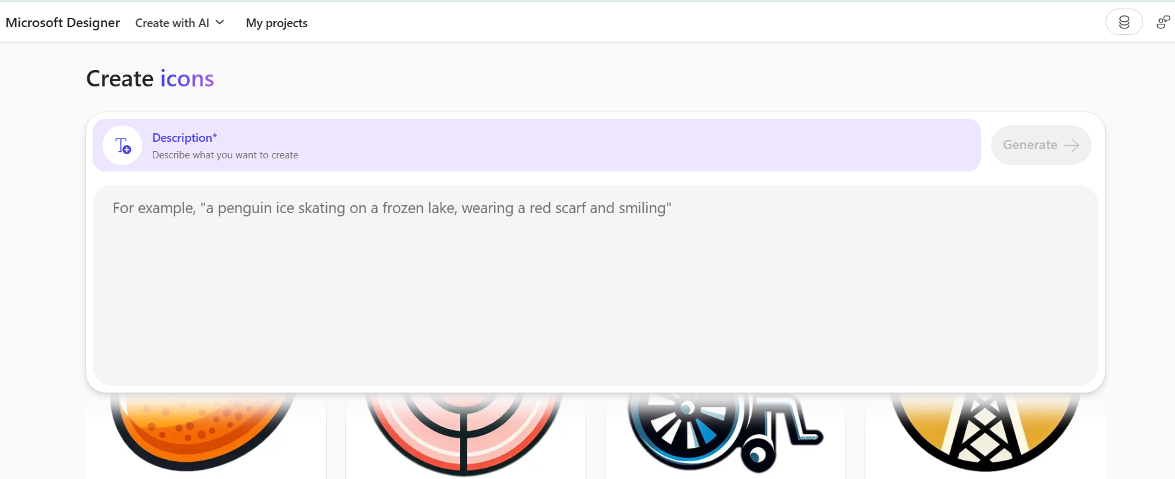

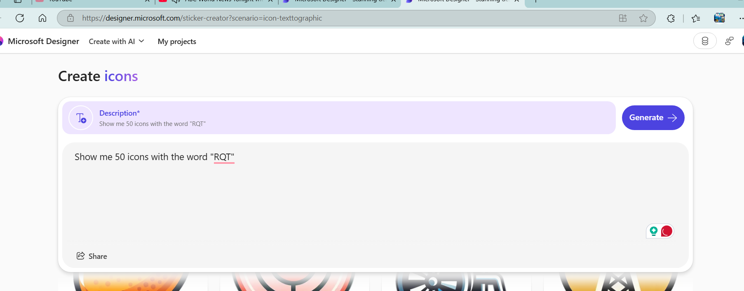

**MS Bing Chat Copilot**

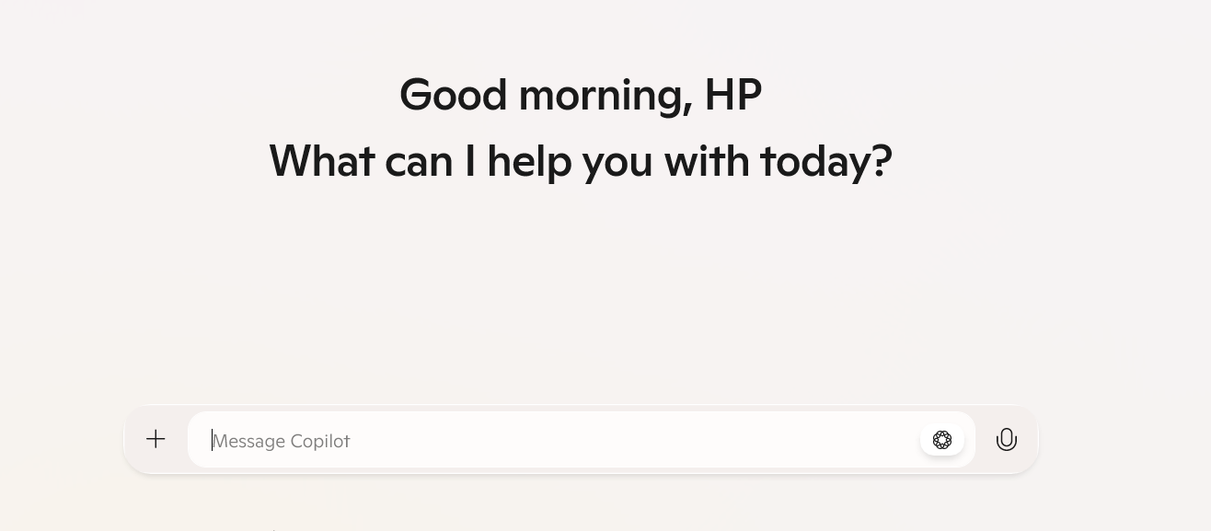

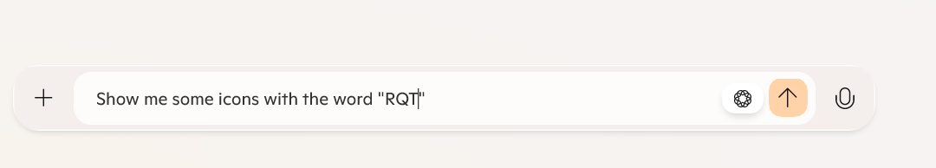

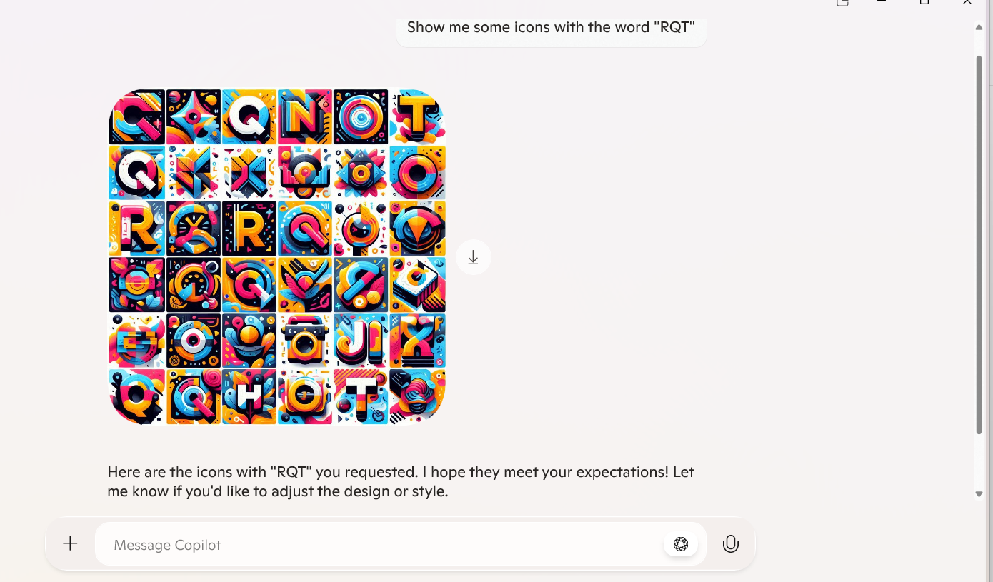

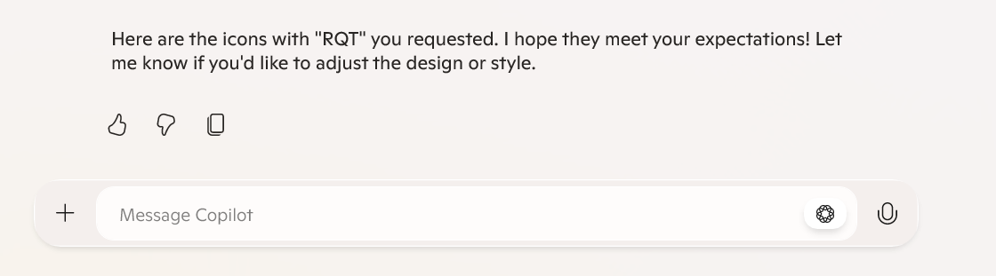

**ChatGPT**

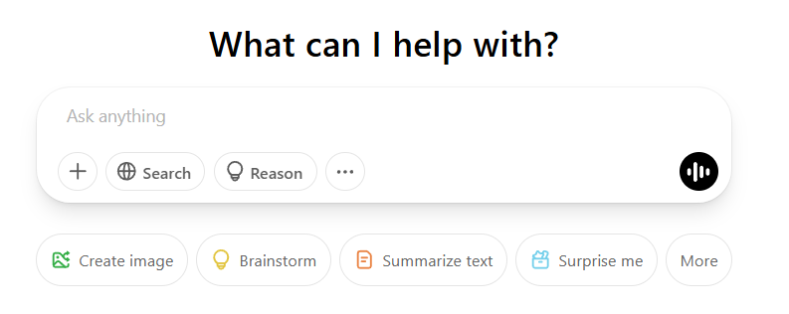

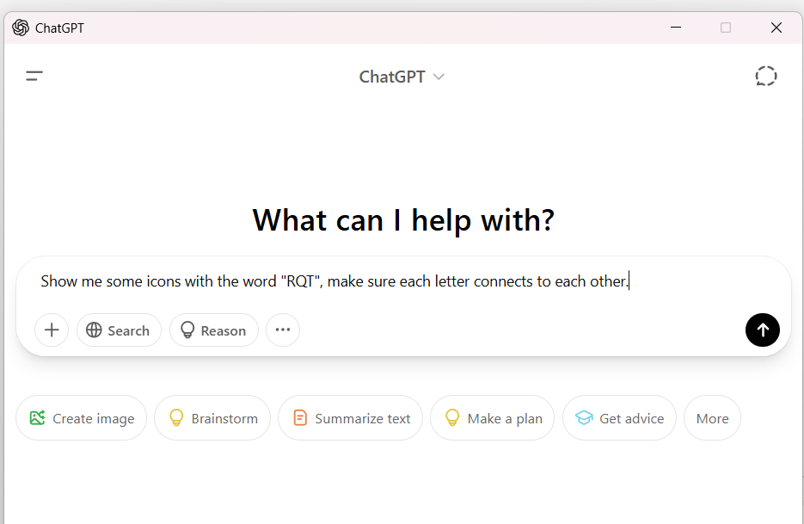

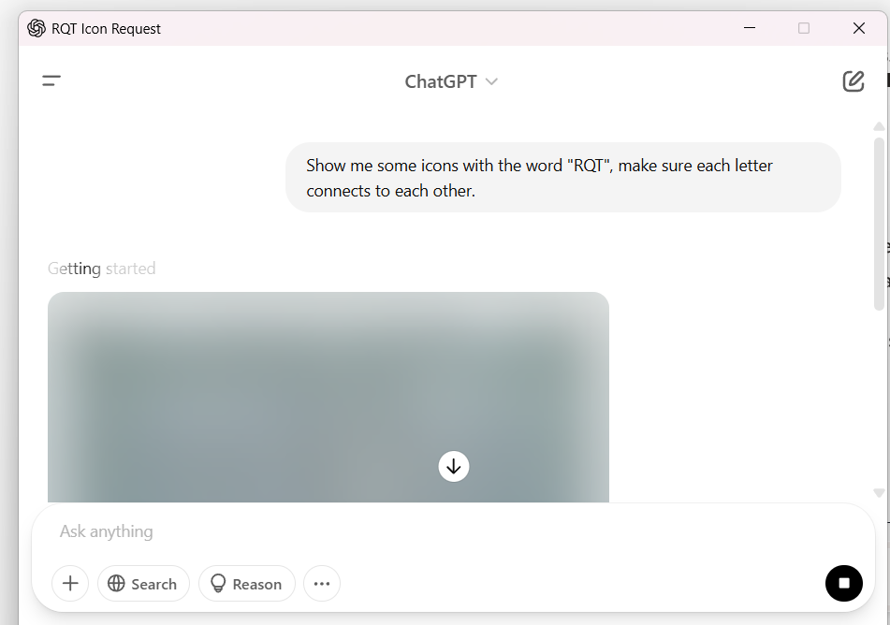

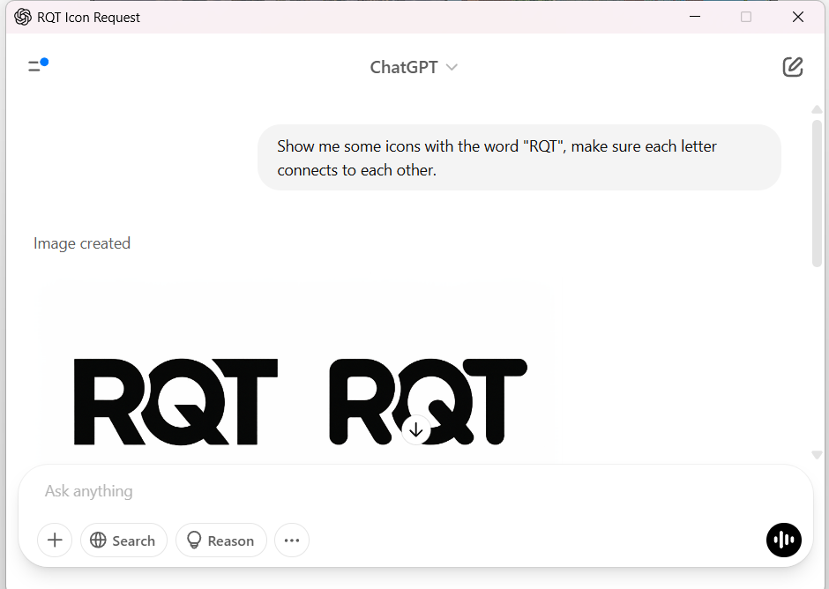

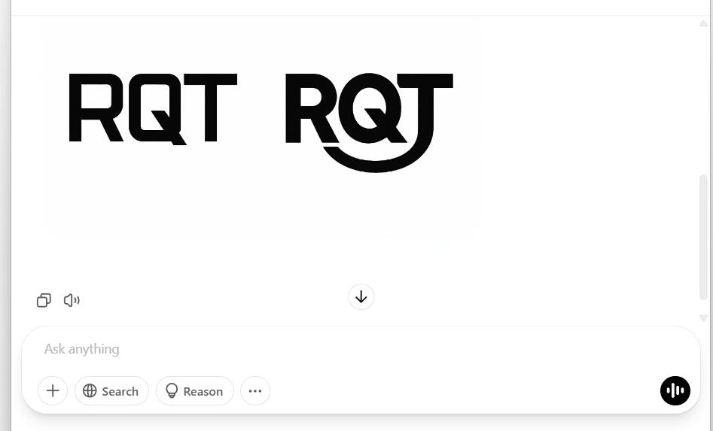

Here’s what the output of the chatbot that I came up with on 04/04/2025 1:33:AM

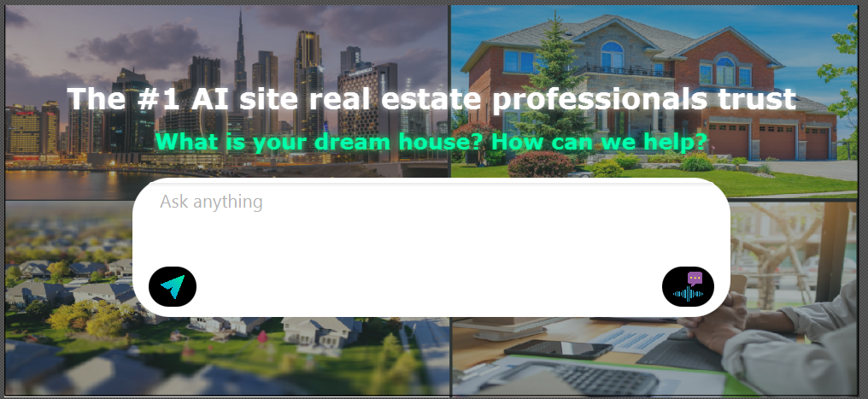

**Notice that the icon that I used for the send button and voice-message button came from website**

[**https://www.flaticon.com/**](https://www.flaticon.com/)

About the chatbot, first, I used VBox that contains TextArea, and BorderPane (2 buttons-1 to the left region, another to the right region)

I used JavaFX’s ImageView to create images, then wrap ImageView into ButtonBar with CSS black background color

**I made the send button, and voice message button activate or remove blue border when an user hover the mouse over it.**

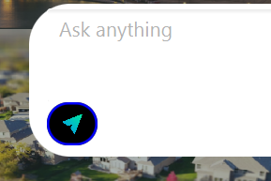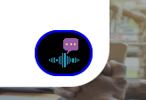

**The cursor for these buttons are “hand” so that the users know that they can click these buttons**

**I also changed the prompt text from the TextArea into “Ask anything or Describe how your dream house may look like. Our AI agent is here 24/7 to help you”**

Below is the design that I finished on 04/04/2025 5:21:PM

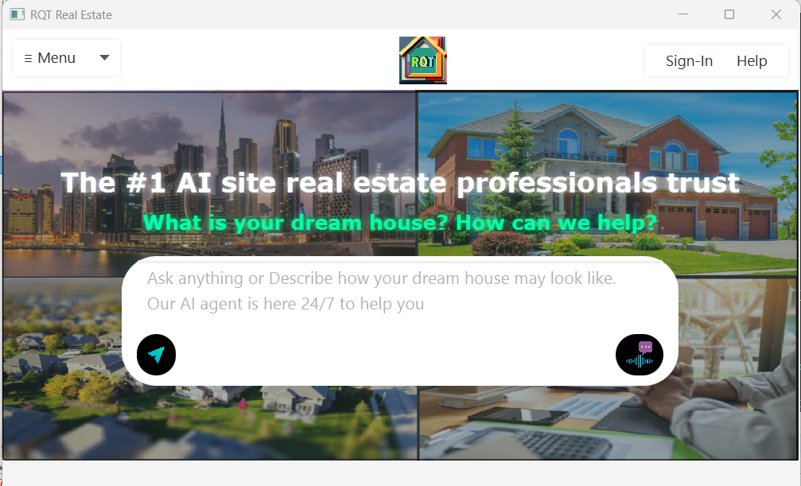

**3.Main page Trending Home container**

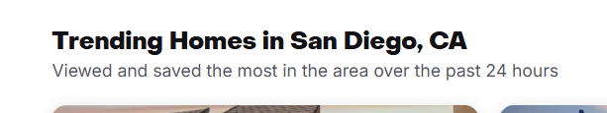 **(Zillow.com)**



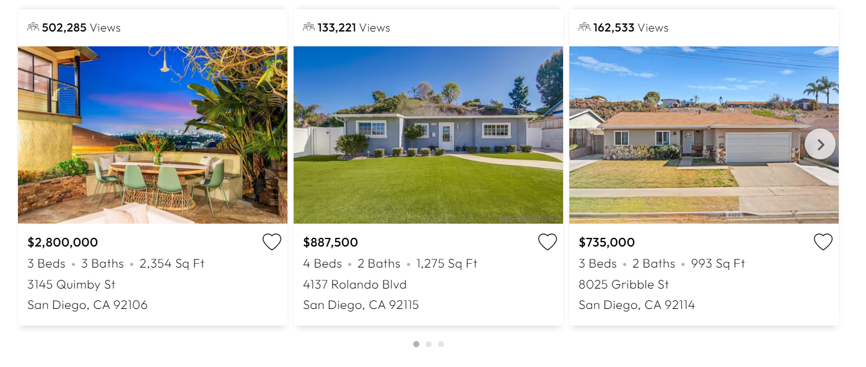

**(**[**www.homes.com**](http://www.homes.com)**)**

**4.Main page calculate budget container**

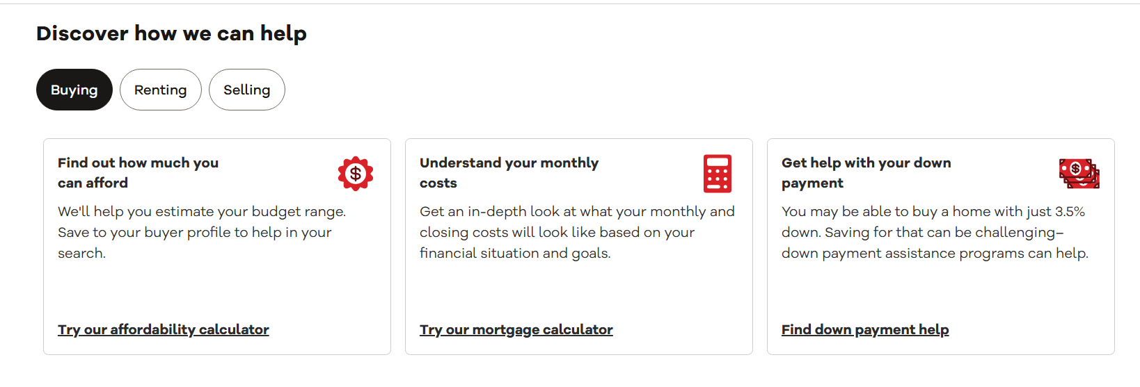

**(**[**www.realtor.com**](http://www.realtor.com)**)**

**5.Main page Agents container**

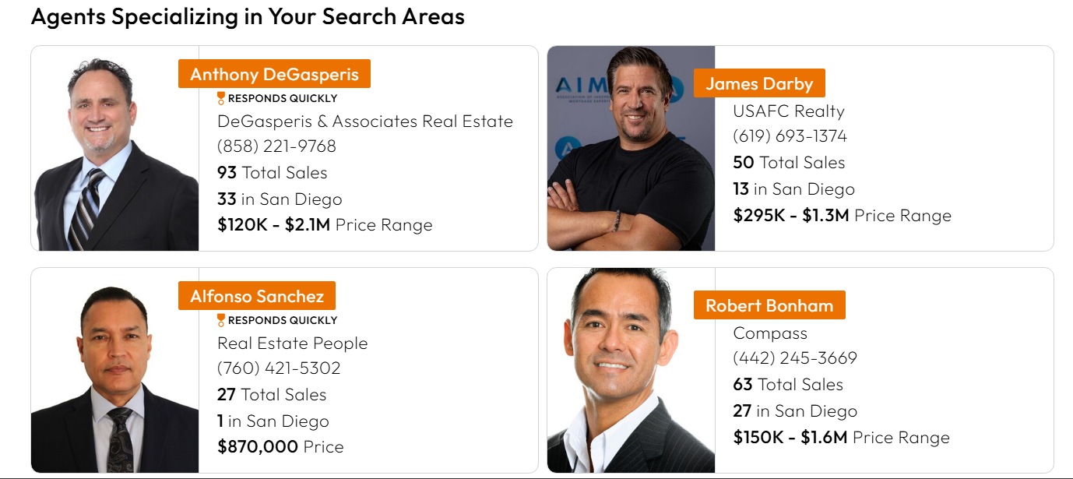

**(**[**www.homes.com**](http://www.homes.com)**)**

**6.Main page Bottom Navigation Container**

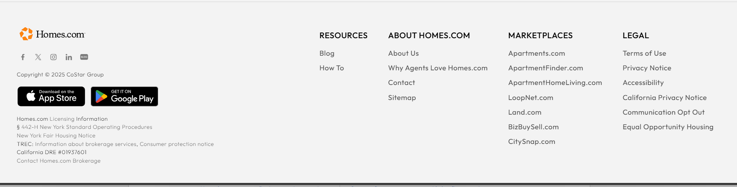

**(www.homes.com)**